**1099 YEAR-END PROCESSING**

Purpose

To set forth the required procedure for districts to use when processing 1099’s for submission to the Internal Revenue Service.

When

1099’s are due to all vendors by the last working day of January for the reporting period ending the previous calendar year.

Procedure

Definition: Form 1099 Misc is used to report earnings by non-employees to the Internal Revenue Service and the State Franchise Tax Board. Reportable earnings are amounts paid in excess of $600.00 for services rendered.

The above definition applies to those individuals who are not employees of your district. Appendix A will help you decide whether the individual is performing services which should be reported on a 1099 or if this person should actually be considered an employee and the earnings reported on a W-2.

TIN: Taxpayer identification numbers are either a social security number or a federal identification number that has been assigned by the Internal Revenue Service.

All vendors are required by law to furnish a TIN. Form W-9 is the official form provided by the IRS for use in requesting TINs. Should a vendor fail to furnish the TIN, backup withholding should be implemented. This means that 31% of the payment is withheld until the vendor returns the completed W-9 form. Appendix B is the IRS guide for backup withholding and contains the procedures as well as the W-9 form. The QSS-OASIS software requires a TIN in order to flag a payment for a 1099. Therefore it is very important to follow through when you give a vendor form W-9.

Form 1099 is issued to vendors to whom you have paid rent (including storage space and equipment), services (including parts and materials), other payments (audits, legal service, advertising, etc.) and medical and health care payments.

Some payments are not required to be reported on Form 1099. These include, but are not limited to: payments to corporations (with the exception of attorneys); payments for merchandise; payments of rent to real estate agents; wages and travel allowances paid to employees; scholarships which are not paid for teaching, research, or other services as a condition for receiving the grant; and fees paid to informants.

**PREPARING FOR THE 1099 PROCESS**

Throughout the CALENDAR year you will make payments to vendors for various services. With each payment try to decide whether or not the services are those which are required to be reported on Form 1099 Misc. These should be flagged when the invoices are paid. By December of each year Information & Technology Services will install the current calendar year version of the 1099 Prelist program. After the installation, you can request a 1099 Prelist using the following steps:

* On the QCC tree select W2/1099 processing
* Click W2/1099 processing
* From the new screen select the appropriate tax year 1099 misc prelist
* On the new screen complete the desired report information

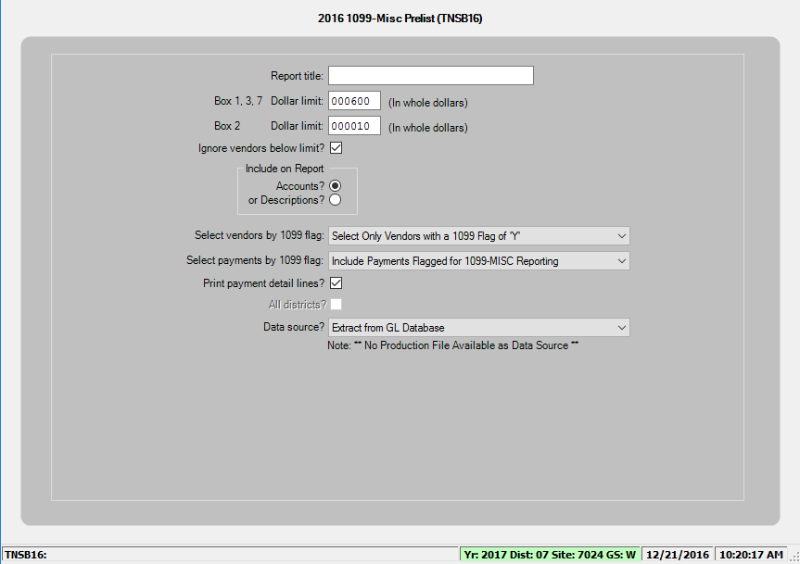

When requesting the report for your first audit, use $1.00 for the dollar limit. Once you have printed the report, audit it to see that amounts excluded are indeed excludable. If an error has been made (either including a payment that should not have been reported or excluding a payment that should have been reported) corrections can be made using the following steps:

* From the Accounts Payable screen, select the option for “Accounts Payable Entries,” (usually option #1).
* Select the option for “1099 Inspection/Maintenance (Update 1099 Flag),” (usually option #8). You should see the screen illustrated below:
* • Valid options for the screen are:
  + 1. o C – Change the 1099 flag
    2. o I – Inspect an APY entry
    3. o E – Exit program

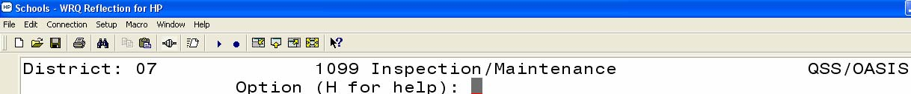

Select option “C” to make a change to the 1099 flag. You will need the warrant number that is associated with the transaction that you want to change. The only data that can be changed on this screen is the 1099 Flag indicator.

After you have changed the 1099 Flag indicator, update and go on to your next change. When all changes have been made, run a new prelist and do another audit. You should repeat this process several times. Keep in mind your final audit prelist can’t be run until after December

31st .

To make certain that all vendors have been properly flagged, run a general ledger report. In order to examine the entire calendar year you must request your general ledger report in prior fiscal year (01/01/XXXX – 06/30/XXXX) and also in the current fiscal year (07/01/XXXX – 12/31/XXXX). Additionally, when you request the subset of accounts, request only 56??, 58??, 61??, and 62??. ***Remember that object code 5200 is to be used for payment to employees for travel and conference expenses***. Payments to non-employees for mileage, travel, etc., should be made from whatever object code is used to pay for the services rendered.

Compare the general ledger report to your 1099 prelist. If there are payments listed in the general ledger that are not reflected on the 1099 prelist, examine the invoice or other documentation/authorization used to make the payment to determine why the vendor was not flagged for a 1099. If the vendor should have been flagged, add the flag through the change option.

Another step in the 1099 process is Foreign Data Entry. This process is useful if you have made payments to the same vendor using two different vendor numbers. It is also used to enter amounts that are not extracted from the general ledger. Examples would be paying an official for a sporting event using student body funds or paying a vendor for services using a Revolving Fund check. It is necessary to obtain this payment information from the person(s) in your district who issues this type of check. You will need to set up a vendor for each of these people as 1099s are extracted from the database using vendor information. Foreign Data Entry is accomplished using the following steps:

* In the Accounts Payable Entries screen, select the option to “Maintain Foreign Data for Tax Year 2005,” (usually option #9).
* Enter the amount paid in the field for Box #7, Nonemployee Comp.

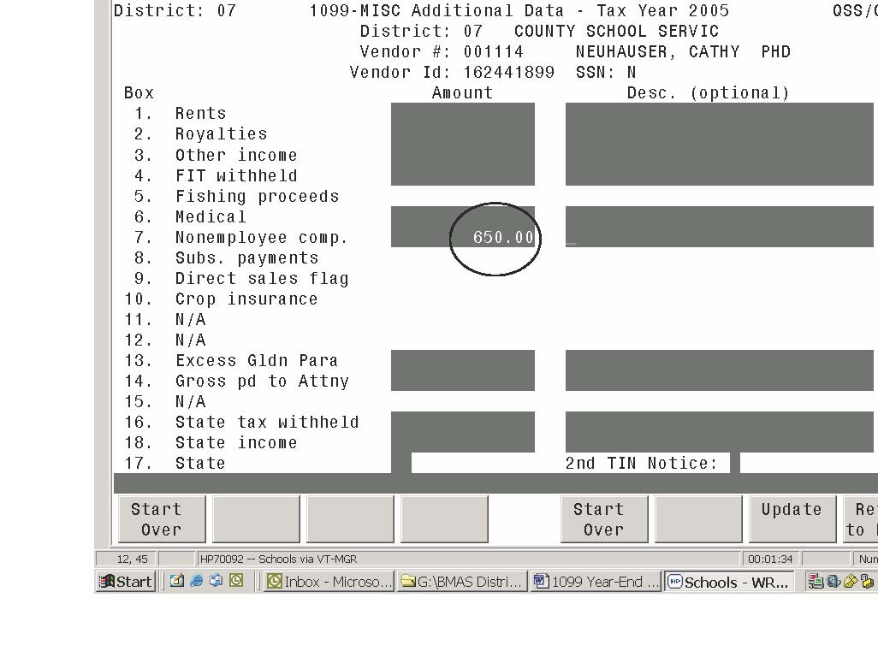

When all corrections have been completed, run a final prelist with a dollar limit of $600.

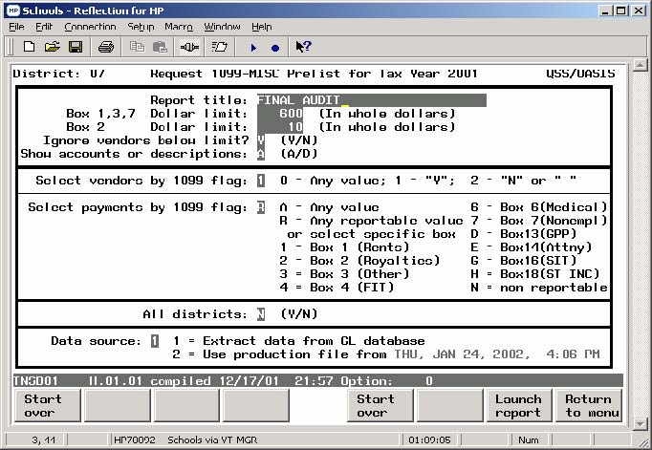

When your final audit is complete, run a final report and call the BMAS department at the YCOE to inform them that you are ready to process 1099s. Route a copy of your prelist to BMAS via the county courier for a final audit. Additionally, you will need to complete the ***Certification of Audit & Authorization to Process 1099’s,*** form which is form AP005.

**APPENDIX A -REPORTING REQUIREMENTS FOR MISCELLANEOUS INCOME**

**TYPE OF PAYMENT**

Accident Insurance

Achievement Awards – Tangible property up to $400 per per employee (non-qualified) Tangible property up to $1600 per Employee (qualified & non-qualified)

Advances on Salary

Athletic Facilities

Auto Reimbursements – over IRS limit Employee Non-employee

Awards -Cash Employee Non-employee

Bonuses Employee Non-employee

Business Expense Reimbursements Accountable Plan Non Accountable Plan Employee Non-employee

Cafeteria Plan Qualified Benefits Cash

Car Expense Employee Non-employee

Car Value Employee Non-employee

Compensation Employee Non-Employee

Consultant Employee Non-employee

**REPORT REPORT ON ON NOT W-2 1099MISC REPORTABLE**

X

X

X

X X

X X

X X

X X

X

X X

XX

X X

X X

X X

X X

**APPENDIX A -REPORTING REQUIREMENTS FOR MISCELLANEOUS INCOME (Cont.)**

**REPORT REPORT ON ON NOT TYPE OF PAYMENT W-2 1099MISC REPORTABLE**

Damage Awards Employee X Non-employee X

Discounts

X Dependent Care X Eating Facilities X Educational Assistance a) not more than $5250 for under grad. classes beginning prior to June 1, 2000 X b) amount over $5250 or classes beginning after June 1, 2000 X Employee Compensation / Wages X Employee Business Expense Reimbursement X Loans to Employees X Meals & Lodging for Employer Convenience X Mileage (over IRS Rate) Employee X Non-Employee X Medical Services X Moving Expenses X Pre-employment Expense Reimbursement X Prizes Employee X Non-Employee X Probationary Pay X Rents X Severance Pay X Sick Pay X Standby Pay X Uniform Allowance X Vacation Allowance X

Payments not reported on Form 1099:

• Payments to corporations (except medical & health care corporations or attorneys)

• Payments for goods

• Payment of rent to real estate agents

* Wages & travel allowances to employees (W-2)
* Scholarships or fellowships (if taxable, use W-2)

• Fees paid to informants as a reward for information on criminal activity

Date Revised: November, 2007 Procedure Binder Section: Accounts Payable

Department of the Treasury

Instructions for the

**Internal Revenue Service**

Requester of Form W-9

(Rev. September 2007)

**Request for Taxpayer Identification Number and Certification**

Section references are to the Internal Revenue Code unless otherwise noted.

**What’s New**

Section 6049 contains new information reporting requirements for tax-exempt interest. For information on certification rules for tax-exempt interest payments, see Notice 2006-93 on page 798 of Internal Revenue Bulletin(I.R.B.) 2006-44 at

*www.irs.gov/pub/irs-irbs/irb06-44.pdf.*

**Reminders**

* The backup withholding rate is 28% for reportable payments.
* The IRS website offers TIN Matching e-services for payers to validate name and TIN combinations. See

*Taxpayer Identification Number (TIN) Matching*

on page 4.

**How Do I Know When To Use Form W-9?**

Use Form W-9 to request the taxpayer identification number (TIN) of a U.S. person (including a resident alien) and to request certain certifications and claims for exemption. (See *Purpose of Form* on Form W-9.) Withholding agents may require signed Forms W-9 from

U.S. exempt recipients to overcome any presumptions of foreign status. For federal purposes, a U.S. person includes but is not limited to:

* An individual who is a U.S. citizen or U.S. resident alien,
* A partnership, corporation, company, or association created or organized in the United States or under the laws of the United States,
* Any estate (other than a foreign estate), or
* A domestic trust (as defined in Regulations section 301.7701-7).

A partnership may require a signed Form W-9 from its

U.S. partners to overcome any presumptions of foreign status and to avoid withholding on the partner’s allocable share of the partnership’s effectively connected income. For more information, see Regulations section 1.1446-1.

Advise foreign persons to use the appropriate Form W-8. See Pub. 515, Withholding of Tax on Nonresident Aliens and Foreign Entities, for more information and a list of the W-8 forms.

Also, a nonresident alien individual may, under certain circumstances, claim treaty benefits on scholarships and fellowship grant income. See Pub. 515 or Pub. 519, U.S. Tax Guide for Aliens, for more information.

**Electronic Submission of Forms W-9**

Requesters may establish a system for payees and payees’ agents to submit Forms W-9 electronically, including by fax. A requester is anyone required to file an information return. A payee is anyone required to provide a taxpayer identification number (TIN) to the requester.

**Payee’s agent.** A payee’s agent can be an investment advisor (corporation, partnership, or individual) or an introducing broker. An investment advisor must be registered with the Securities Exchange Commission (SEC) under the Investment Advisers Act of 1940. The introducing broker is a broker-dealer that is regulated by the SEC and the National Association of Securities Dealers, Inc., and that is not a payer. Except for a broker who acts as a payee’s agent for “readily tradable instruments,” the advisor or broker must show in writing to the payer that the payee authorized the advisor or broker to transmit the Form W-9 to the payer.

**Electronic system.** Generally, the electronic system must:

* Ensure the information received is the information sent, and document all occasions of user access that result in the submission;
* Make reasonably certain that the person accessing the system and submitting the form is the person identified on Form W-9, the investment advisor, or the introducing broker;
* Provide the same information as the paper Form W-9;
* Be able to supply a hard copy of the electronic Form W-9 if the Internal Revenue Service requests it; and
* Require as the final entry in the submission an electronic signature by the payee whose name is on Form W-9 that authenticates and verifies the submission. The electronic signature must be under penalties of perjury and the perjury statement must contain the language of the paper Form W-9.

*For Forms W-9 that are not required to be signed, the electronic system need not provide for an electronic signature or a perjury statement.*

For more details, see the following.

* Announcement 98-27 on page 30 of I.R.B. 1998-15 available at *www.irs.gov/pub/irs-irbs/irb98-15.pdf*.
* Announcement 2001-91 on page 221 of I.R.B. 2001-36 available at *www.irs.gov/pub/irs-irbs/irb01-36.pdf*.

**Individual Taxpayer Identification Number (ITIN)**

Form W-9 (or an acceptable substitute) is used by persons required to file information returns with the IRS to get the payee’s (or other person’s) correct name and

Cat. No. 20479P

TIN. For individuals, the TIN is generally a social security page 22 of I.R.B. 1996-8 at number (SSN). *www.irs.gov/pub/irs-irbs/irb96-08.pdf*.

However, in some cases, individuals who become U.S. resident aliens for tax purposes are not eligible to obtain an SSN. This includes certain resident aliens who must receive information returns but who cannot obtain an SSN.

These individuals must apply for an ITIN on Form W-7, Application for IRS Individual Taxpayer Identification Number, unless they have an application pending for an SSN. Individuals who have an ITIN must provide it on Form W-9.

**Substitute Form W-9**

You may develop and use your own Form W-9 (a substitute Form W-9) if its content is substantially similar to the official IRS Form W-9 and it satisfies certain certification requirements.

You may incorporate a substitute Form W-9 into other business forms you customarily use, such as account signature cards. However, the certifications on the substitute Form W-9 must clearly state (as shown on the official Form W-9) that under penalties of perjury:

1. The payee’s TIN is correct,

2. The payee is not subject to backup withholding due to failure to report interest and dividend income, and

3. The payee is a U.S. person.

You may not:

1. Use a substitute Form W-9 that requires the payee, by signing, to agree to provisions unrelated to the required certifications, or
2. Imply that a payee may be subject to backup withholding unless the payee agrees to provisions on the substitute form that are unrelated to the required certifications.

A substitute Form W-9 that contains a separate signature line just for the certifications satisfies the requirement that the certifications be clearly stated.

If a single signature line is used for the required certifications and other provisions, the certifications must be highlighted, boxed, printed in bold-face type, or presented in some other manner that causes the language to stand out from all other information contained on the substitute form. Additionally, the following statement must be presented to stand out in the same manner as described above and must appear immediately above the single signature line:

“The Internal Revenue Service does not require your consent to any provision of this document other than the certifications required to avoid backup withholding.”

If you use a substitute form, you are required to provide the Form W-9 instructions to the payee only if he or she requests them. However, if the IRS has notified the payee that backup withholding applies, then you must instruct the payee to strike out the language in the certification that relates to underreporting. This instruction can be given orally or in writing. See item 2 of the *Certification* on Form W-9. You can replace “defined below” with “defined in the instructions” in item 3 of the *Certification* on Form W-9 when the instructions will not be provided to the payee except upon request. For more information, see Revenue Procedure 83-89,1983-2, C.B. 613; amplified by Revenue Procedure 96-26 which is on

**TIN Applied for**

For interest and dividend payments and certain payments with respect to readily tradable instruments, the payee may return a properly completed, signed Form W-9 to you with “Applied For” written in Part I. This is an “awaiting-TIN” certificate. The payee has 60 calendar days, from the date you receive this certificate, to provide a TIN. If you do not receive the payee’s TIN at that time, you must begin backup withholding on payments.

**Reserve rule.** You must backup withhold on any reportable payments made during the 60-day period if a payee withdraws more than $500 at one time, unless the payee reserves 28 percent of all reportable payments made to the account.

**Alternative rule.** You may also elect to backup withhold during this 60-day period, after a 7-day grace period, under one of the two alternative rules discussed below.

***Option 1.*** Backup withhold on any reportable payments if the payee makes a withdrawal from the account after the close of 7 business days after you receive the awaiting-TIN certificate. Treat as reportable payments all cash withdrawals in an amount up to the reportable payments made from the day after you receive the awaiting-TIN certificate to the day of withdrawal.

***Option 2.*** Backup withhold on any reportablepayments made to the payee’s account, regardless of whether the payee makes any withdrawals, beginning no later than 7 business days after you receive the awaiting-TIN certificate.

*The 60-day exemption from backup withholding does not apply to any payment other than interest, dividends, and certain payments relating to readily tradable instruments. Any other reportable payment, such as nonemployee compensation, is subject to backup withholding immediately, even if the payee has applied for and is awaiting a TIN.*

*Even if the payee gives you an awaiting-TIN certificate, you must backup withhold on reportable interest and dividend payments if the payee does not certify, under penalties of perjury, that the payee is not subject to backup withholding.*

*If you do not collect backup withholdings from affected payees as required, you may become liable for any uncollected amount.*

**Payees Exempt From Backup Withholding**

Even if the payee does not provide a TIN in the manner required, you are not required to backup withhold on any payments you make if the payee is:

1. An organization exempt from tax under section 501(a), any IRA where the payor is also the trustee or custodian, or a custodial account under section 403(b)(7) if the account satisfies the requirements of section 401(f)(2),
2. The United States or any of its agencies or instrumentalities,
3. A state, the District of Columbia, a possession of the United States, or any of their political subdivisions or instrumentalities,

**-2­**

4. A foreign government or any of its political • Payments of patronage dividends not paid in money. subdivisions, agencies, or instrumentalities, or • Payments made by certain foreign organizations.

5. An international organization or any of its agencies

• Section 404(k) distributions made by an ESOP.

or instrumentalities.

Other payees that may be exempt from backup withholding include:

6. A corporation,

7. A foreign central bank of issue,

8. A dealer in securities or commodities required to register in the United States, the District of Columbia, or a possession of the United States,

9. A futures commission merchant registered with the Commodity Futures Trading Commission,

10. A real estate investment trust,

11. An entity registered at all times during the tax year under the Investment Company Act of 1940,

12. A common trust fund operated by a bank under section 584(a),

13. A financial institution,

14. A middleman known in the investment community as a nominee or custodian, or

15. A trust exempt from tax under section 664 or described in section 4947.

The following types of payments are exempt from backup withholding as indicated for items 1 through 15 above.

**Interest and dividend payments.** All listed payees are exempt except the payee in item 9.

**Broker transactions.** All payees listed in items 1 through 13 are exempt. A person registered under the Investment Advisers Act of 1940 who regularly acts as a broker is also exempt.

**Barter exchange transactions and patronage dividends.** Only payees listed in items 1 through 5 are exempt.

**Payments reportable under sections 6041 and 6041A.**

Only payees listed in items 1 through 7 are generally exempt.

However, the following payments made to a corporation (including gross proceeds paid to an attorney under section 6045(f), even if the attorney is a corporation) and reportable on Form 1099-MISC, Miscellaneous Income, are not exempt from backup withholding.

* Medical and health care payments.
* Attorneys’ fees.
* Payments for services paid by a federal executive agency. (See Revenue Ruling 2003-66 on page 1115 in

I.R.B. 2003-26 at *www.irs.gov/pub/irs-irbs/irb03-26.pdf*.)

**Payments Exempt From Backup Withholding**

Payments that are not subject to information reporting also are not subject to backup withholding. For details, see sections 6041, 6041A, 6042, 6044, 6045, 6049, 6050A, and 6050N, and their regulations. The following payments are generally exempt from backup withholding.

**Dividends and patronage dividends**

* Payments to nonresident aliens subject to withholding under section 1441.
* Payments to partnerships not engaged in a trade or business in the United States and that have at least one nonresident alien partner.

**Interest payments**

* Payments of interest on obligations issued by individuals. However, if you pay $600 or more of interest in the course of your trade or business to a payee, you must report the payment. Backup withholding applies to the reportable payment if the payee has not provided a TIN or has provided an incorrect TIN.
* Payments described in section 6049(b)(5) to nonresident aliens.
* Payments on tax-free covenant bonds under section 1451.
* Payments made by certain foreign organizations.
* Mortgage or student loan interest paid to you.

**Other types of payment**

* Wages.
* Distributions from a pension, annuity, profit-sharing or stock bonus plan, any IRA where the payor is also the trustee or custodian, an owner-employee plan, or other deferred compensation plan.
* Distributions from a medical or health savings account and long-term care benefits.
* Certain surrenders of life insurance contracts.
* Distribution from qualified tuition programs or Coverdell ESAs.
* Gambling winnings if regular gambling winnings withholding is required under section 3402(q). However, if regular gambling winnings withholding is not required under section 3402(q), backup withholding applies if the payee fails to furnish a TIN.
* Real estate transactions reportable under section 6045(e).
* Cancelled debts reportable under section 6050P.
* Fish purchases for cash reportable under section 6050R.
* Certain payment card transactions by a qualified payment card agent (as described in Revenue Procedure 2004-42 and Regulations section 31.3406(g)-1(f) and if the requirements under Regulations section 31.3406(g)-1(f) are met. Revenue Procedure 2004-42 is on page 121 of I.R.B. 2004-31 which is available at *www.irs.gov/pub/irs-irbs/irb04-31.pdf*.

**Joint Foreign Payees**

If the first payee listed on an account gives you a Form W-8 or a similar statement signed under penalties of perjury, backup withholding applies unless:

1. Every joint payee provides the statement regarding foreign status, or
2. Any one of the joint payees who has not established foreign status gives you a TIN.

If any one of the joint payees who has not established foreign status gives you a TIN, use that number for purposes of backup withholding and information reporting.

For more information on foreign payees, see the Instructions for the Requester of Forms W-8BEN, W-8ECI, W-8EXP, and W-8IMY.

**-3­**

**Names and TINs To Use for Information Reporting**

Show the full name and address as provided on Form W-9 on the information return filed with the IRS and on the copy furnished to the payee. If you made payments to more than one payee or the account is in more than one name, enter on the first name line only the name of the payee whose TIN is shown on the information return. You may show the names of any other individual payees in the area below the first name line.

**Sole proprietor.** Enter the individual’s name on the first name line. On the second name line, enter the business name or “doing business as (DBA)” if provided. You may not enter only the business name. For the TIN, you may enter either the individual’s SSN or the employer identification number (EIN) of the business. However, the IRS encourages you to use the SSN.

**LLC.** For an LLC that is disregarded as an entity separate from its owner, you must show the owner’s name on the first name line. On the second name line, you may enter the LLC’s name. Use the owner’s TIN. Do not enter the disregarded entity’s EIN.

**Notices From the IRS**

The IRS will send you a notice if the payee’s name and TIN on the information return you filed do not match the IRS’s records. (See *Taxpayer Identification Number (TIN) Matching* below.) You may have to send a “B” notice to the payee to solicit another TIN. Pub. 1281, Backup Withholding for Missing and Incorrect Name/TIN(s), contains copies of the two types of “B” notices.

**Taxpayer Identification Number (TIN) Matching**

TIN Matching allows a payer or authorized agent who is required to file Forms 1099-B, DIV, INT, MISC, OID, and /or PATR to match TIN and name combinations with IRS records before submitting the forms to the IRS. TIN Matching is one of the e-services products that is offered, and is accessible through the IRS website. Go to *www.irs.gov* and search for “e-services.” It is anticipated that payers who validate the TIN and name combinations before filing information returns will receive fewer backup withholding (CP2100) “B” notices and penalty notices.

**Additional Information**

For more information on backup withholding, see Pub. 1281.

**-4­**

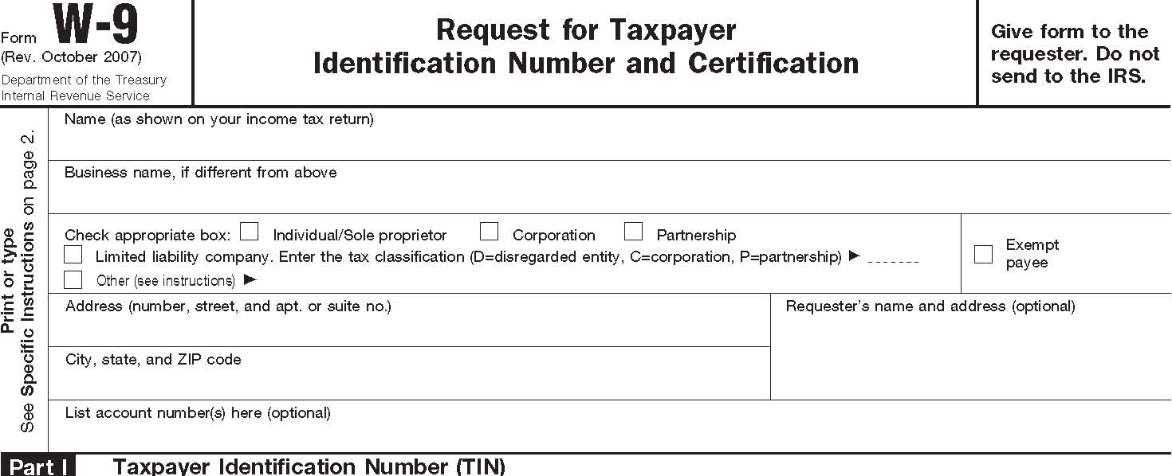

**Taxpayer Identification Number (TIN)**

Enter your TIN in the appropriate box. The TIN provided must match the name given on Line 1 to avoid backup withholding. For individuals, this is your social security number (SSN). However, for a resident alien, sole proprietor, or disregarded entity, see the Part I instructions on page 3. For other entities, it is



**or**

your employer identification number (EIN). If you do not have a number, see *How to get a TIN* on page 3.



**Certification**

Under penalties of perjury, I certify that:

1. The number shown on this form is my correct taxpayer identification number (or I am waiting for a number to be issued to me), and

2. I am not subject to backup withholding because: (a) I am exempt from backup withholding, or (b) I have not been notified by the Internal Revenue Service (IRS) that I am subject to backup withholding as a result of a failure to report all interest or dividends, or (c) the IRS has notified me that I am no longer subject to backup withholding, and

3. I am a U.S. citizen or other U.S. person (defined below).

**Certification instructions.** You must cross out item 2 above if you have been notified by the IRS that you are currently subject to backup withholding because you have failed to report all interest and dividends on your tax return. For real estate transactions, item 2 does not apply. For mortgage interest paid, acquisition or abandonment of secured property, cancellation of debt, contributions to an individual retirement arrangement (IRA), and generally, payments other than interest and dividends, you are not required to sign the Certification, but you must provide your correct TIN. See the instructions on page 4.

**Sign**

**Signature of**

**Here**

**U.S. person Date**

**General Instructions**

Section references are to the Internal Revenue Code unless otherwise noted.

**Purpose of Form**

A person who is required to file an information return with the IRS must obtain your correct taxpayer identification number (TIN) to report, for example, income paid to you, real estate transactions, mortgage interest you paid, acquisition or abandonment of secured property, cancellation of debt, or contributions you made to an IRA.

Use Form W-9 only if you are a U.S. person (including a resident alien), to provide your correct TIN to the person requesting it (the requester) and, when applicable, to:

1. Certify that the TIN you are giving is correct (or you are waiting for a number to be issued),
2. Certify that you are not subject to backup withholding, or
3. Claim exemption from backup withholding if you are a U.S. exempt payee. If applicable, you are also certifying that as a

U.S. person, your allocable share of any partnership income from a U.S. trade or business is not subject to the withholding tax on foreign partners’ share of effectively connected income.

**Note.** If a requester gives you a form other than Form W-9 to request your TIN, you must use the requester’s form if it is substantially similar to this Form W-9.

**Definition of a U.S. person.** For federal tax purposes, you are considered a U.S. person if you are:

* An individual who is a U.S. citizen or U.S. resident alien,
* A partnership, corporation, company, or association created or organized in the United States or under the laws of the United States,
* An estate (other than a foreign estate), or
* A domestic trust (as defined in Regulations section 301.7701-7).

**Special rules for partnerships.** Partnerships that conduct a trade or business in the United States are generally required to pay a withholding tax on any foreign partners’ share of income from such business. Further, in certain cases where a Form W-9 has not been received, a partnership is required to presume that a partner is a foreign person, and pay the withholding tax. Therefore, if you are a U.S. person that is a partner in a partnership conducting a trade or business in the United States, provide Form W-9 to the partnership to establish your U.S. status and avoid withholding on your share of partnership income.

The person who gives Form W-9 to the partnership for purposes of establishing its U.S. status and avoiding withholding on its allocable share of net income from the partnership conducting a trade or business in the United States is in the following cases:

● The U.S. owner of a disregarded entity and not the entity,

Cat. No. 10231X Form **W-9** (Rev. 10-2007) Form W-9 (Rev. 10-2007) Page **2**

* The U.S. grantor or other owner of a grantor trust and not the trust, and
* The U.S. trust (other than a grantor trust) and not the beneficiaries of the trust.

**Foreign person.** If you are a foreign person, do not use Form W-9. Instead, use the appropriate Form W-8 (see Publication 515, Withholding of Tax on Nonresident Aliens and Foreign Entities).

**Nonresident alien who becomes a resident alien.** Generally, only a nonresident alien individual may use the terms of a tax treaty to reduce or eliminate U.S. tax on certain types of income. However, most tax treaties contain a provision known as a “saving clause.” Exceptions specified in the saving clause may permit an exemption from tax to continue for certain types of income even after the payee has otherwise become a U.S. resident alien for tax purposes.

If you are a U.S. resident alien who is relying on an exception contained in the saving clause of a tax treaty to claim an exemption from U.S. tax on certain types of income, you must attach a statement to Form W-9 that specifies the following five items:

1. The treaty country. Generally, this must be the same treaty under which you claimed exemption from tax as a nonresident alien.
2. The treaty article addressing the income.
3. The article number (or location) in the tax treaty that contains the saving clause and its exceptions.
4. The type and amount of income that qualifies for the exemption from tax.
5. Sufficient facts to justify the exemption from tax under the terms of the treaty article.

***Example.*** Article 20 of the U.S.-China income tax treaty allows an exemption from tax for scholarship income received by a Chinese student temporarily present in the United States. Under

U.S. law, this student will become a resident alien for tax purposes if his or her stay in the United States exceeds 5 calendar years. However, paragraph 2 of the first Protocol to the U.S.-China treaty (dated April 30, 1984) allows the provisions of Article 20 to continue to apply even after the Chinese student becomes a resident alien of the United States. A Chinese student who qualifies for this exception (under paragraph 2 of the first protocol) and is relying on this exception to claim an exemption from tax on his or her scholarship or fellowship income would attach to Form W-9 a statement that includes the information described above to support that exemption.

If you are a nonresident alien or a foreign entity not subject to backup withholding, give the requester the appropriate completed Form W-8.

**What is backup withholding?** Persons making certain payments to you must under certain conditions withhold and pay to the IRS 28% of such payments. This is called “backup withholding.” Payments that may be subject to backup withholding include interest, tax-exempt interest, dividends, broker and barter exchange transactions, rents, royalties, nonemployee pay, and certain payments from fishing boat operators. Real estate transactions are not subject to backup withholding.

You will not be subject to backup withholding on payments you receive if you give the requester your correct TIN, make the proper certifications, and report all your taxable interest and dividends on your tax return.

**Payments you receive will be subject to backup withholding if:**

1. You do not furnish your TIN to the requester,
2. You do not certify your TIN when required (see the Part II instructions on page 3 for details),
3. The IRS tells the requester that you furnished an incorrect TIN,
4. The IRS tells you that you are subject to backup withholding because you did not report all your interest and dividends on your tax return (for reportable interest and dividends only), or
5. You do not certify to the requester that you are not subject to backup withholding under 4 above (for reportable interest and dividend accounts opened after 1983 only).

Certain payees and payments are exempt from backup withholding. See the instructions below and the separate Instructions for the Requester of Form W-9.

Also see *Special rules for partnerships* on page 1.

**Penalties**

**Failure to furnish TIN.** If you fail to furnish your correct TIN to a requester, you are subject to a penalty of $50 for each such failure unless your failure is due to reasonable cause and not to willful neglect.

**Civil penalty for false information with respect to withholding.** If you make a false statement with no reasonable basis that results in no backup withholding, you are subject to a $500 penalty.

**Criminal penalty for falsifying information.** Willfully falsifying certifications or affirmations may subject you to criminal penalties including fines and/or imprisonment.

**Misuse of TINs.** If the requester discloses or uses TINs in violation of federal law, the requester may be subject to civil and criminal penalties.

**Specific Instructions Name**

If you are an individual, you must generally enter the name shown on your income tax return. However, if you have changed your last name, for instance, due to marriage without informing the Social Security Administration of the name change, enter your first name, the last name shown on your social security card, and your new last name.

If the account is in joint names, list first, and then circle, the name of the person or entity whose number you entered in Part I of the form.

**Sole proprietor.** Enter your individual name as shown on your income tax return on the “Name” line. You may enter your business, trade, or “doing business as (DBA)” name on the “Business name” line.

**Limited liability company (LLC).** Check the “Limited liability company” box only and enter the appropriate code for the tax classification (“D” for disregarded entity, “C” for corporation, “P” for partnership) in the space provided.

For a single-member LLC (including a foreign LLC with a domestic owner) that is disregarded as an entity separate from its owner under Regulations section 301.7701-3, enter the owner’s name on the “Name” line. Enter the LLC’s name on the “Business name” line.

For an LLC classified as a partnership or a corporation, enter the LLC’s name on the “Name” line and any business, trade, or DBA name on the “Business name” line.

**Other entities.** Enter your business name as shown on required federal tax documents on the “Name” line. This name should match the name shown on the charter or other legal document creating the entity. You may enter any business, trade, or DBA name on the “Business name” line.

**Note.** You are requested to check the appropriate box for your status (individual/sole proprietor, corporation, etc.).

**Exempt Payee**

If you are exempt from backup withholding, enter your name as described above and check the appropriate box for your status, then check the “Exempt payee” box in the line following the business name, sign and date the form.

Form W-9 (Rev. 10-2007) Page **3**

Generally, individuals (including sole proprietors) are not exempt from backup withholding. Corporations are exempt from backup withholding for certain payments, such as interest and dividends.

**Note.** If you are exempt from backup withholding, you should still complete this form to avoid possible erroneous backup withholding.

The following payees are exempt from backup withholding:

1. An organization exempt from tax under section 501(a), any IRA, or a custodial account under section 403(b)(7) if the account satisfies the requirements of section 401(f)(2),
2. The United States or any of its agencies or instrumentalities,
3. A state, the District of Columbia, a possession of the United States, or any of their political subdivisions or instrumentalities,
4. A foreign government or any of its political subdivisions, agencies, or instrumentalities, or
5. An international organization or any of its agencies or instrumentalities.

Other payees that may be exempt from backup withholding include:

1. A corporation,
2. A foreign central bank of issue,
3. A dealer in securities or commodities required to register in the United States, the District of Columbia, or a possession of the United States,
4. A futures commission merchant registered with the Commodity Futures Trading Commission,
5. A real estate investment trust,
6. An entity registered at all times during the tax year under the Investment Company Act of 1940,
7. A common trust fund operated by a bank under section 584(a),
8. A financial institution,
9. A middleman known in the investment community as a nominee or custodian, or
10. A trust exempt from tax under section 664 or described in section 4947.

The chart below shows types of payments that may be exempt from backup withholding. The chart applies to the exempt payees listed above, 1 through 15.

|  |  |  |
| --- | --- | --- |
| **IF the payment is for . . .** | **THEN the payment is exempt for . . .** | |
| Interest and dividend payments | All exempt payees except for 9 | |
| Broker transactions | Exempt payees 1 through 13. Also, a person registered under the Investment Advisers Act of 1940 who regularly acts as a broker | |
| Barter exchange transactions and patronage dividends | Exempt payees 1 through 5 | |
| Payments over $600 required to be reported and direct sales over $5,0001 | Generally, exempt payees 1 through 7 2 | |

1

See Form 1099-MISC, Miscellaneous Income, and its instructions.

2

However, the following payments made to a corporation (including gross proceeds paid to an attorney under section 6045(f), even if the attorney is a corporation) and reportable on Form 1099-MISC are not exempt from backup withholding: medical and health care payments, attorneys’ fees, and payments for services paid by a federal executive agency.

**Part I. Taxpayer Identification Number (TIN)**

**Enter your TIN in the appropriate box.** If you are a resident alien and you do not have and are not eligible to get an SSN, your TIN is your IRS individual taxpayer identification number (ITIN). Enter it in the social security number box. If you do not have an ITIN, see *How to get a TIN* below.

If you are a sole proprietor and you have an EIN, you may enter either your SSN or EIN. However, the IRS prefers that you use your SSN.

If you are a single-member LLC that is disregarded as an entity separate from its owner (see *Limited liability company (LLC)* on page 2), enter the owner’s SSN (or EIN, if the owner has one). Do not enter the disregarded entity’s EIN. If the LLC is classified as a corporation or partnership, enter the entity’s EIN.

**Note.** See the chart on page 4 for further clarification of name

and TIN combinations. **How to get a TIN.** If you do not have a TIN, apply for one immediately. To apply for an SSN, get Form SS-5, Application for a Social Security Card, from your local Social Security Administration office or get this form online at *www.ssa.gov*. You may also get this form by calling 1-800-772-1213. Use Form W-7, Application for IRS Individual Taxpayer Identification Number, to apply for an ITIN, or Form SS-4, Application for Employer Identification Number, to apply for an EIN. You can apply for an EIN online by accessing the IRS website at *www.irs.gov/businesses* and clicking on Employer Identification Number (EIN) under Starting a Business. You can get Forms W-7 and SS-4 from the IRS by visiting *www.irs.gov* or by calling 1-800-TAX-FORM (1-800-829-3676).

If you are asked to complete Form W-9 but do not have a TIN, write “Applied For” in the space for the TIN, sign and date the form, and give it to the requester. For interest and dividend payments, and certain payments made with respect to readily tradable instruments, generally you will have 60 days to get a TIN and give it to the requester before you are subject to backup withholding on payments. The 60-day rule does not apply to other types of payments. You will be subject to backup withholding on all such payments until you provide your TIN to the requester.

**Note.** Entering “Applied For” means that you have already applied for a TIN or that you intend to apply for one soon.

**Caution:** *A disregarded domestic entity that has a foreign owner must use the appropriate Form W-8.*

**Part II. Certification**

To establish to the withholding agent that you are a U.S. person, or resident alien, sign Form W-9. You may be requested to sign by the withholding agent even if items 1, 4, and 5 below indicate otherwise.

For a joint account, only the person whose TIN is shown in Part I should sign (when required). Exempt payees, see *Exempt Payee* on page 2.

**Signature requirements.** Complete the certification as indicated in 1 through 5 below.

1. **Interest, dividend, and barter exchange accounts opened before 1984 and broker accounts considered active during 1983.** You must give your correct TIN, but you do not have to sign the certification.
2. **Interest, dividend, broker, and barter exchange accounts opened after 1983 and broker accounts considered inactive during 1983.** You must sign the certification or backup withholding will apply. If you are subject to backup withholding and you are merely providing your correct TIN to the requester, you must cross out item 2 in the certification before signing the form.

Form W-9 (Rev. 10-2007) Page **4**

1. **Real estate transactions.** You must sign the certification. You may cross out item 2 of the certification.
2. **Other payments.** You must give your correct TIN, but you do not have to sign the certification unless you have been notified that you have previously given an incorrect TIN. “Other payments” include payments made in the course of the requester’s trade or business for rents, royalties, goods (other than bills for merchandise), medical and health care services (including payments to corporations), payments to a nonemployee for services, payments to certain fishing boat crew members and fishermen, and gross proceeds paid to attorneys (including payments to corporations).
3. **Mortgage interest paid by you, acquisition or abandonment of secured property, cancellation of debt, qualified tuition program payments (under section 529), IRA, Coverdell ESA, Archer MSA or HSA contributions or distributions, and pension distributions.** You must give your correct TIN, but you do not have to sign the certification.

**What Name and Number To Give the Requester**

|  |  |
| --- | --- |
| **For this type of account:** | **Give name and SSN of:** |
| 1. Individual | The individual |
| 2. Two or more individuals (joint | The actual owner of the account or, |
| account) | if combined funds, the first individual on the account 1 |
| 3. Custodian account of a minor | The minor 2 |
| (Uniform Gift to Minors Act) |  |
| 4. a. The usual revocable savings | The grantor-trustee 1 |
| trust (grantor is also trustee) |  |
| b. So-called trust account that is | The actual owner 1 |
| not a legal or valid trust under |  |
| state law |  |
| 5. Sole proprietorship or disregarded | The owner 3 |
| entity owned by an individual |  |
| **For this type of account:** | **Give name and EIN of:** |
| A valid trust, estate, or pension trust 6. Corporate or LLC electing corporate status on Form 8832 7. Association, club, religious, charitable, educational, or other tax-exempt organization 8. Partnership or multi-member LLC 9. A broker or registered nominee 10. Account with the Department of Agriculture in the name of a public entity (such as a state or local government, school district, or prison) that receives agricultural program payments 11. Disregarded entity not owned by an individual 12. | Legal entity 4 The corporation The organization The partnership The broker or nominee The public entity The owner |

**Secure Your Tax Records from Identity Theft**

Identity theft occurs when someone uses your personal information such as your name, social security number (SSN), or other identifying information, without your permission, to commit fraud or other crimes. An identity thief may use your SSN to get a job or may file a tax return using your SSN to receive a refund.

To reduce your risk:

* Protect your SSN,
* Ensure your employer is protecting your SSN, and
* Be careful when choosing a tax preparer.

Call the IRS at 1-800-829-1040 if you think your identity has been used inappropriately for tax purposes.

Victims of identity theft who are experiencing economic harm or a system problem, or are seeking help in resolving tax problems that have not been resolved through normal channels, may be eligible for Taxpayer Advocate Service (TAS) assistance. You can reach TAS by calling the TAS toll-free case intake line at 1-877-777-4778 or TTY/TDD 1-800-829-4059.

**Protect yourself from suspicious emails or phishing schemes.** Phishing is the creation and use of email and websites designed to mimic legitimate business emails and websites. The most common act is sending an email to a user falsely claiming to be an established legitimate enterprise in an attempt to scam the user into surrendering private information that will be used for identity theft.

The IRS does not initiate contacts with taxpayers via emails. Also, the IRS does not request personal detailed information through email or ask taxpayers for the PIN numbers, passwords, or similar secret access information for their credit card, bank, or other financial accounts.

If you receive an unsolicited email claiming to be from the IRS, forward this message to *phishing@irs.gov.* You may also report misuse of the IRS name, logo, or other IRS personal property to the Treasury Inspector General for Tax Administration at 1-800-366-4484. You can forward suspicious emails to the Federal Trade Commission at: *spam@uce.gov* or contact them at *www.consumer.gov/idtheft* or 1-877-IDTHEFT(438-4338).

Visit the IRS website at *www.irs.gov* to learn more about identity theft and how to reduce your risk.

1

List first and circle the name of the person whose number you furnish. If only one person on a joint account has an SSN, that person’s number must be furnished.

2

Circle the minor’s name and furnish the minor’s SSN.

3

You must show your individual name and you may also enter your business or “DBA” name on the second name line. You may use either your SSN or EIN (if you have one), but the IRS encourages you to use your SSN.

4

List first and circle the name of the trust, estate, or pension trust. (Do not furnish the TIN of the personal representative or trustee unless the legal entity itself is not designated in the account title.) Also see *Special rules for partnerships* on page 1.

**Note.** If no name is circled when more than one name is listed, the number will be considered to be that of the first name listed.

**Privacy Act Notice**

Section 6109 of the Internal Revenue Code requires you to provide your correct TIN to persons who must file information returns with the IRS to report interest, dividends, and certain other income paid to you, mortgage interest you paid, the acquisition or abandonment of secured property, cancellation of debt, or contributions you made to an IRA, or Archer MSA or HSA. The IRS uses the numbers for identification purposes and to help verify the accuracy of your tax return. The IRS may also provide this information to the Department of Justice for civil and criminal litigation, and to cities, states, the District of Columbia, and U.S. possessions to carry out their tax laws. We may also disclose this information to other countries under a tax treaty, to federal and state agencies to enforce federal nontax criminal laws, or to federal law enforcement and intelligence agencies to combat terrorism.

You must provide your TIN whether or not you are required to file a tax return. Payers must generally withhold 28% of taxable interest, dividend, and certain other payments to a payee who does not give a TIN to a payer. Certain penalties may also apply.